**Work -Digital Image Processing Software Usage**

**Program 1:**

Open the software contained root folder in command line as given below in screen shot:

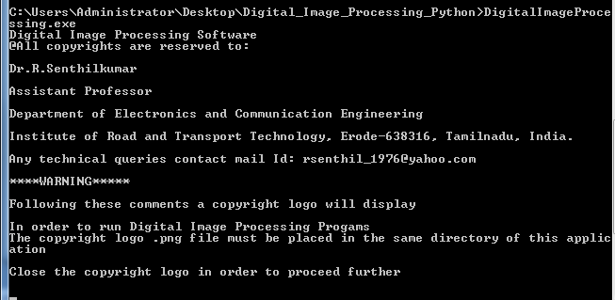

Copyright logo

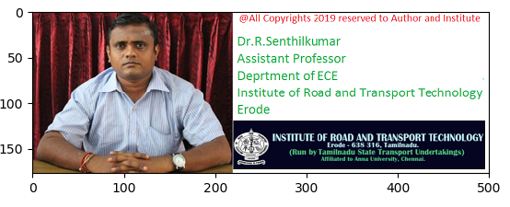

After the closing above figure, the following commands will be displayed in the command window:

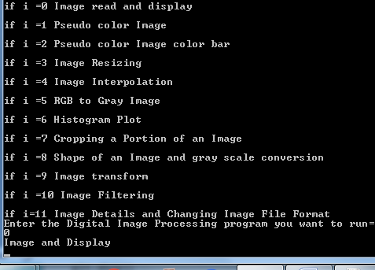

Result: Image and Display

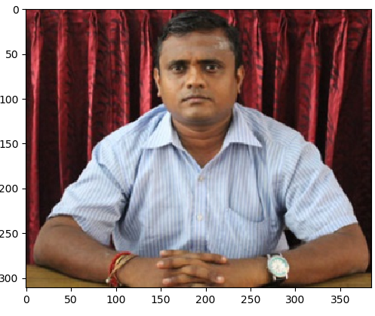

**Program 2: Pseudo Color Image**

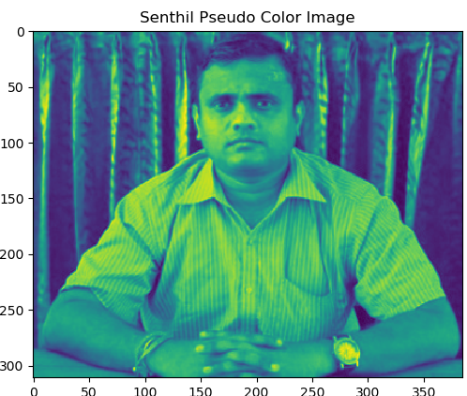

**Program 3: Pseudo color Image color bar**

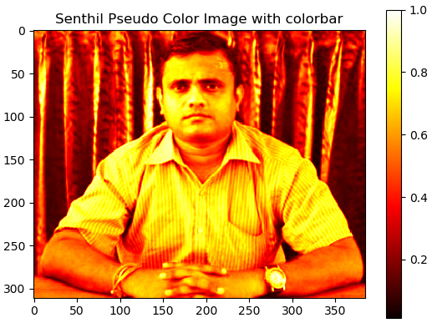

**Program 4: Image Resizing**

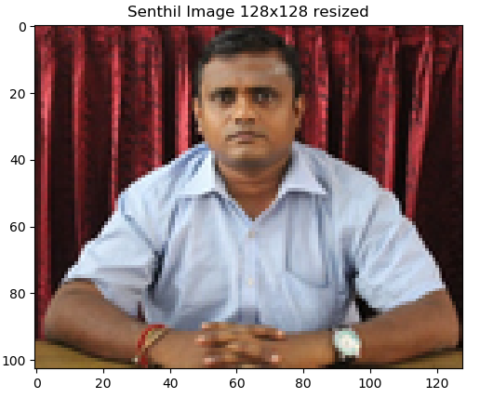

**Program 5: Image Interpolation**

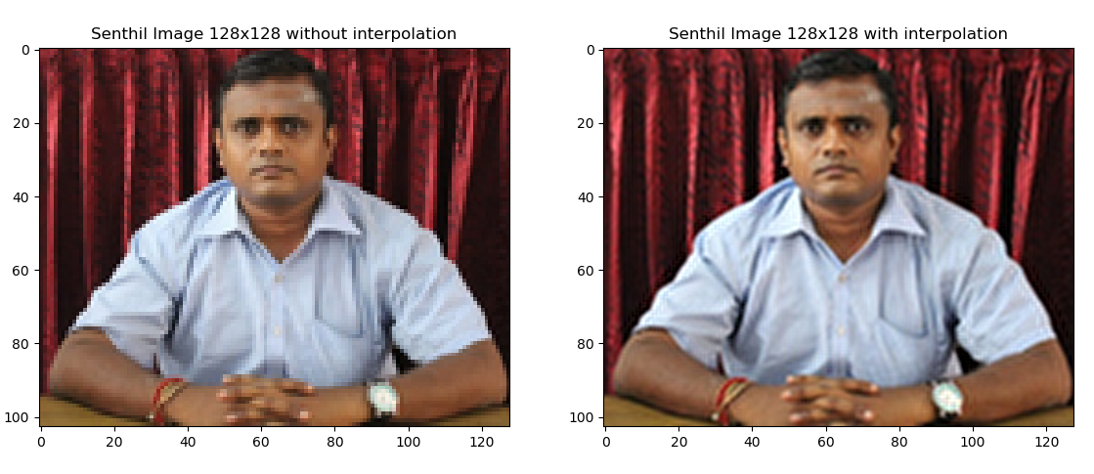

**Program 6: RGB to Gray Image**

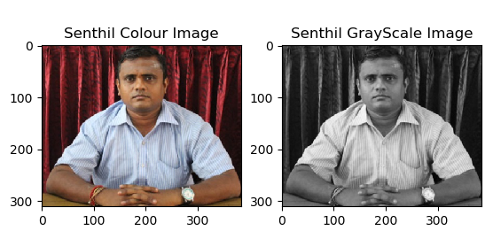

**Program 7: Histogram Plot**

**Result 1:**

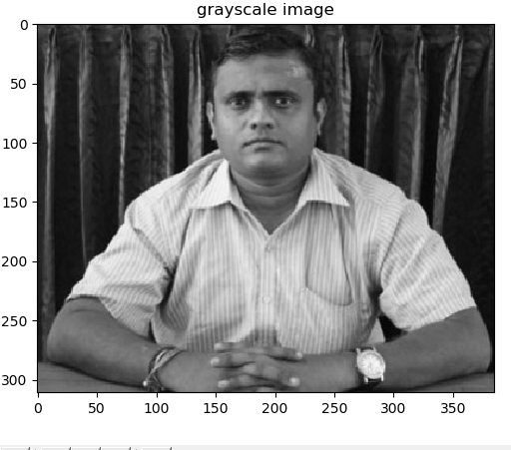

**Result 2:**

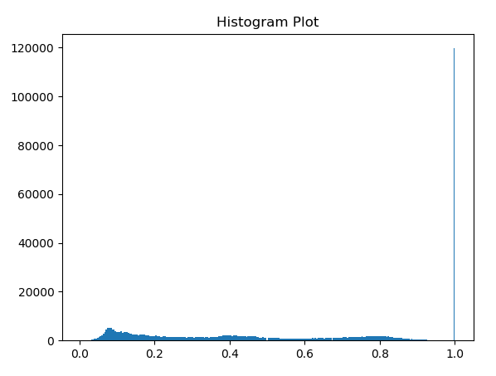

**Program 8: Cropping a Portion of and Image**

**Result:**

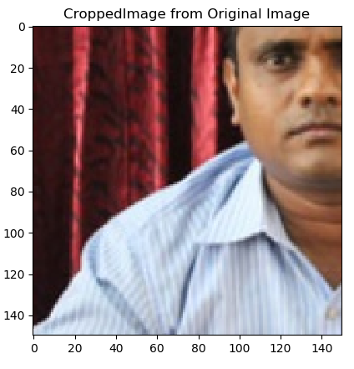

**Program 9: Shape of an Image and Gray Scale Conversion**

**Result 1:**

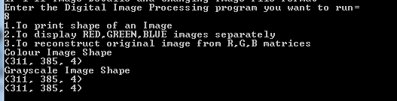

**Result 2:**

**Original Colour Image**

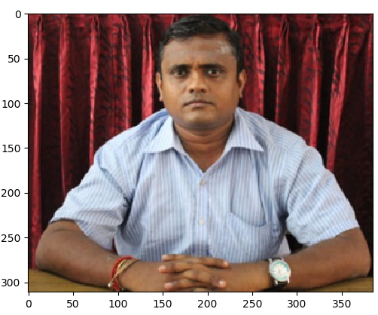

**Result 3: GrayScale Image**

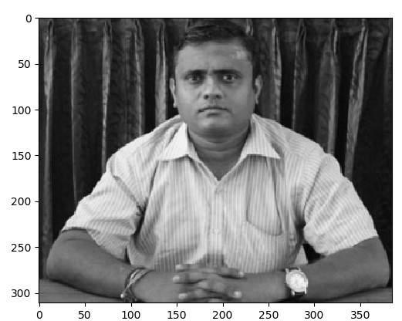

**Result 4:**

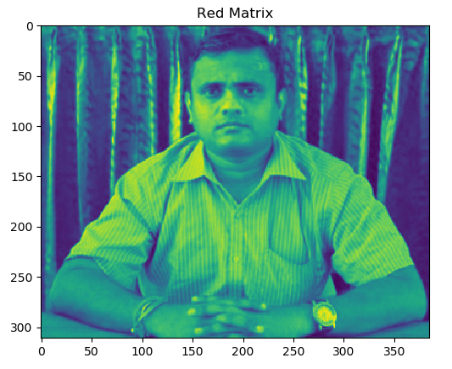

**Result 5:**

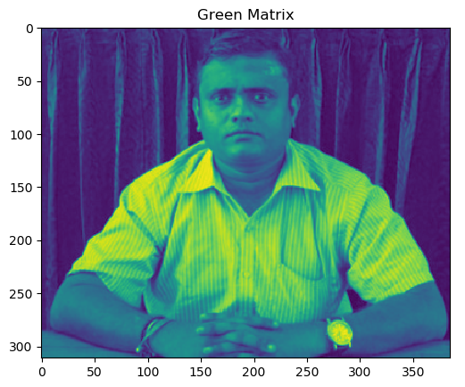

**Result 6:**

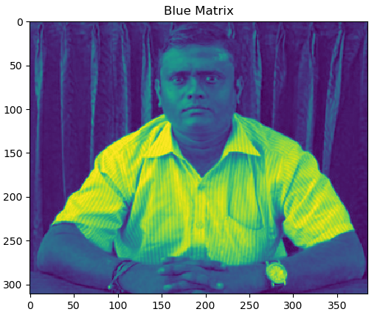

**Result 7: Reconstructed colour Image From Red, Green, Blue matrices**

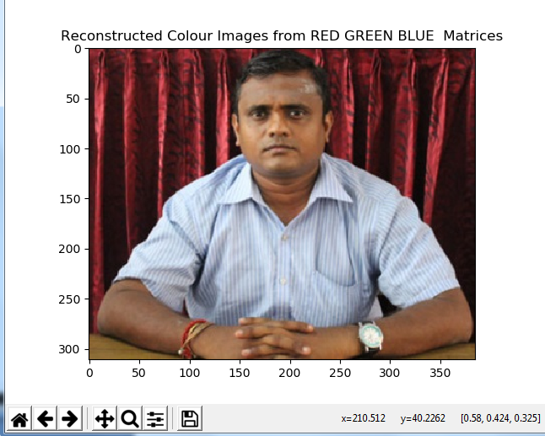

**Program 10: Image Transform**

**Result 1:**

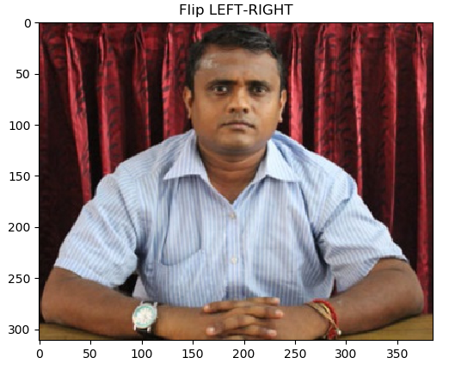

**Result 2:**

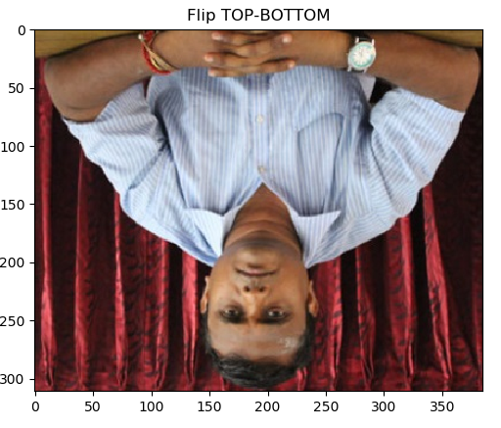

**Result 3:**

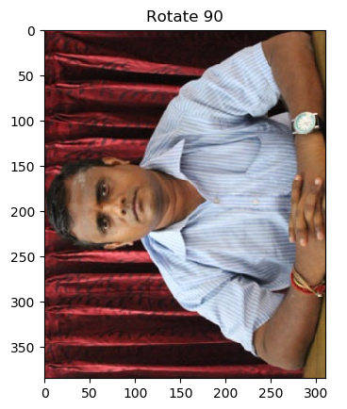

**Result 4:**

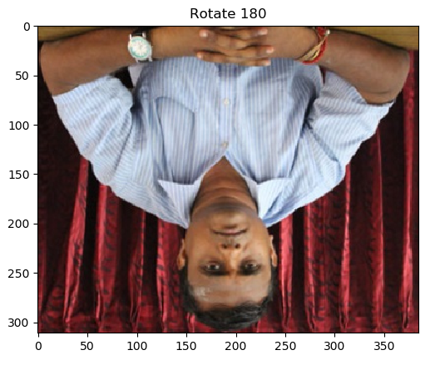

**Result 5:  
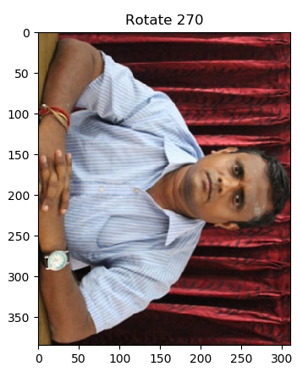**

**Program 11: Image Filtering**

**Result 1:**

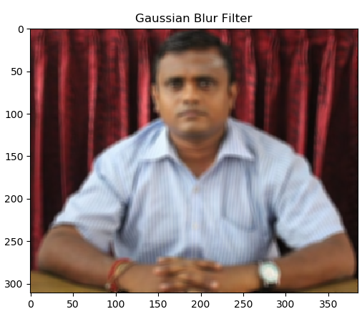

**Result 2:**

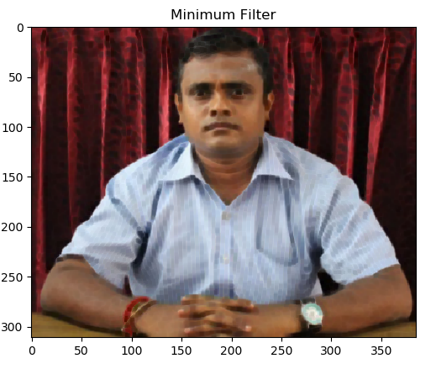

**Result 3:**

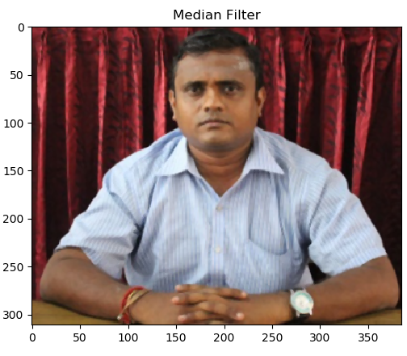

**Result 4:**

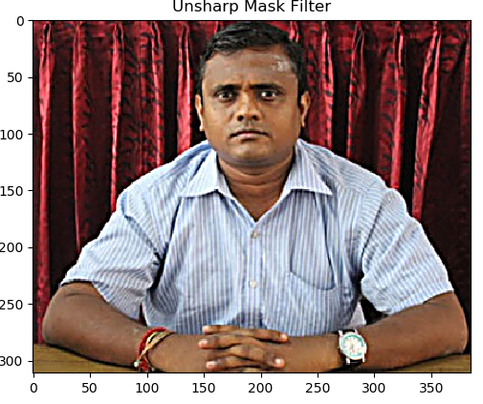

**Program 12: Image Details and Changing Image File Format**

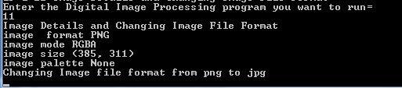

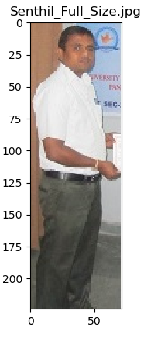 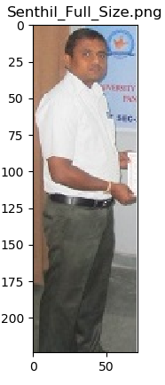

Converted Image file format from .jpg to .png